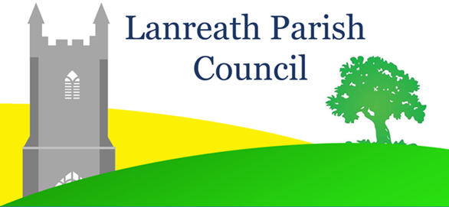
Face to Face Meetings
Covid 19 Risk Assessment
The Risk Level of any identified hazard is normally determined by evaluating both the probability and the consequences of a hazard occurring, taking into consideration the barriers that are already in place to mitigate the risk. A risk matrix is typically used to determine the Risk Level. Hazards that have a high probability of occurrence, combined with serious consequences if they do occur, would have a High risk level on the matrix. A High risk level represents an intolerable risk that requires additional safeguarding barriers to be put in place to mitigate either the probability of occurrence, or the severity of the consequences.
The high probability and serious consequences of transmitting Covid 19 at a face-to face Parish Council, under normal circumstances, poses a High risk to those attending and, therefore, additional risk mitigation barriers are required to drive the risk to a tolerable level.

HAZARD | WHO MAY BE HARMED | ADDITIONAL BARRIERS | WHO IS RESONSIBLE
Covid 19 transmission via aerosols / droplets | Councillors  Parish Clerk  Public attendees | - Social distancing to be observed on entering / leaving the hall and during the meeting.  - Face masks to be worn on entering the hall and throughout the meeting.  - Chair spacing at least 2 metres apart.  - No chairs facing each other.  - Adequate ventilation – open windows and external doors.  - No person may attend if they or their households have developed Covid 19 symptoms within the last 10 days.  - No more than two persons to use each suite of toilets at one time.  - Clinically vulnerable individuals discouraged from attending.  - Clinically vulnerable councillors to be encouraged to offer apologies for absence.  - Those wishing to attend who have not had at least one Covid vaccination should consider submitting queries / observations on agenda items or other issues by email to the Parish Clerk ahead of the meeting rather than attending in person.  - Maximum of 12 public attendees to permit safe chair spacing. Those wishing to attend requested to inform Clerk by email prior to meeting. | - All attendees  - All attendees  - Chair to set up ahead of meeting  - Chair to set up ahead of meeting  - Chair to set up ahead of meeting  - All potential attendees - promulgated in Covid Safe Procedure’  - All attendees  - Members of the public – promulgated in ‘Covid Safe Procedure’  - Individual Councillors  - Potential attendees – promulgated in ‘Covid Safe Procedure’  - Managed by Chair in consultation with Clerk and promulgated in ‘Covid Safe Procedure’
Covid 19 transmission via hard surfaces | Councillors  Parish Clerk  Public attendees  Cleaners  Subsequent Hall user groups. | - Hand sanitiser at hall entrance and in the meeting room.  - Door handles, chairs, tables, light switches and wash basins cleaned with sanitiser wipes before and after the meeting.  - No shared paperwork -agenda to be displayed via pc and projector.  - Hand sanitiser to be used before signing Acceptance of Office Register at separate table using own pen.  - Anyone displaying Covid symptoms or who has a positive Covid test within 7 days of attending a meeting to inform the Parish Clerk | - Chair or nominated councillor to arrange and check prior to meeting.  - Chair plus one other councillor.  - Chair to set up ahead of meeting.  - Chair to set up ahead of meeting  - All attendees promulgated in ‘Covid Safe Procedure’

